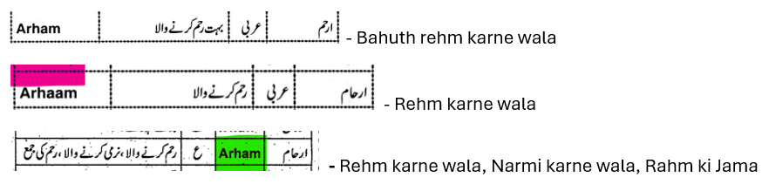

Faayiz - Kaamiyab, Jeetha hua

- fayidah

- fayidah

Faayiz – Kaamiyab

فیض Faiz عطیہ، کرم

khushi

khushi

فرحت Farhat خوشی

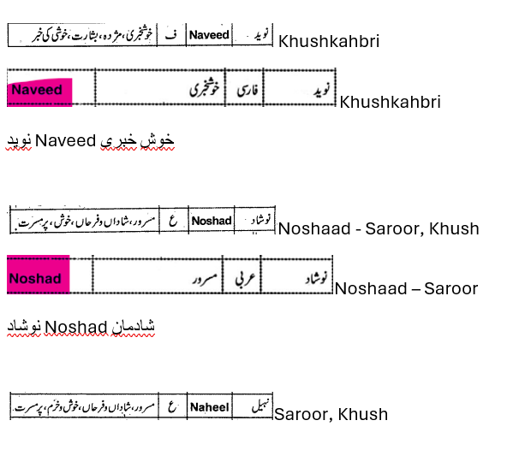

Zayaan - wajaahath, husn

- buland marthabe/izzath wala, shaan wa shoukhath wala

buland marthabe wala

Zeeshah - Shaan/ruthbah wala

 Zahaaq- bahuth zyaada hasne wala

Zaahaq - hansne wala, hansthe hua

Zaahaq - hansne wala, hansthe hua

****Zahaaq- bahuth zyaada hasne wala

ضحّاک Zahhak ہنسنے والا